Double Pendulum:

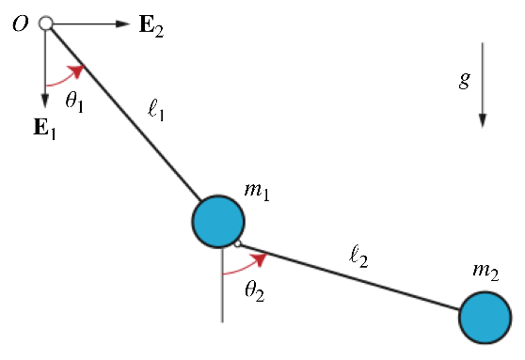

## Kinematics

Position:

Velocity:

## Energy

Potential Energy:

Kinetic Energy:

## LaGrange Equation:

## Control System Friendly Format:

The angular acceleration of the first link was controlled by an actuator near the anchor point. This actuator is reflected in the term added to the equations of motion.

Note: there are “cross-terms” in the angular acceleration equations (in , and in ). This gave me a headache when designing the “obey physics” constraints for collocated control. In the single pendulum example, we can begin writing these constraints like this:

Since we have no dependence of on similar ordered terms, we can end the “obey-physics” constraints here at each control step .

I tried to use these instead:

Where the constraint equations for and are not first-order approximations.

This does not seem to be working though.

Solution: Uncouple the terms

We can express by substituting the expression for of the 2nd equation into the 1st:

We can express by substituting the expression for of the 1st equation into the 2nd: